**DAY 6 CC - PERSONAL NOTES APPLICATION**

**Personal Notes Application with the following functionalities:**

1. State Management using Context API.

2. Hooks for Managing State and Side Effects.

3. PWA Implementation with Service Workers for Offline Support.

4. Persist Data using LocalStorage.

**ADD A NOTE:**

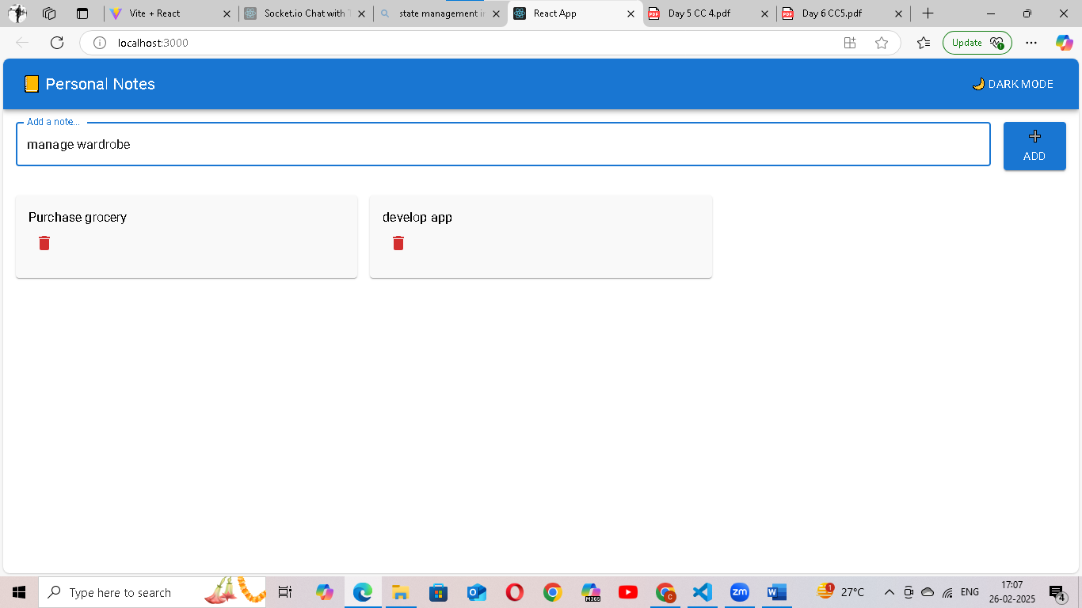

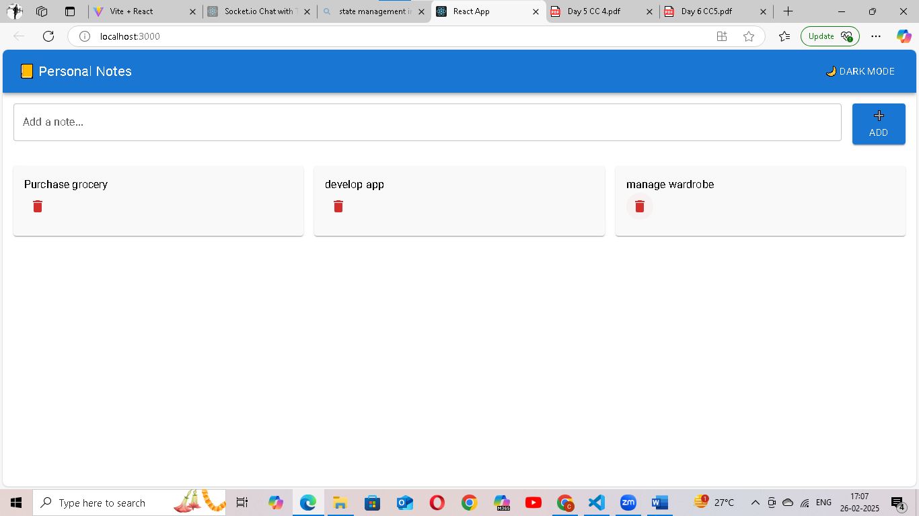

**DELETE A NOTE:**

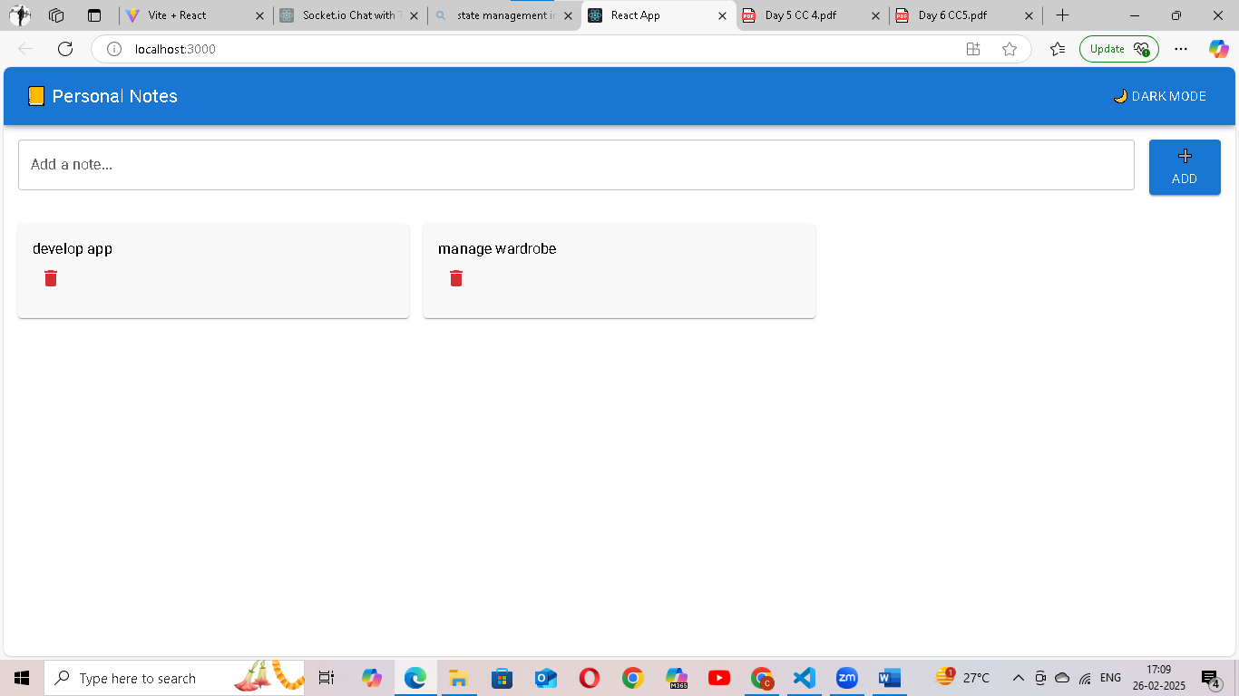

**DARK MODE:**

